MirrorMate
Jake Hochstadt, Ryan Moreland, Matt Simons, and Jerome Yearwood

Department of Electrical Engineering and Computer Science, University of Central Florida, Orlando, Florida, 32816-2450

Abstract — MirrorMate is an interactive rear view mirror designed to assist drivers and provide helpful information in a convenient location. Among the key features are an integrated full color LCD screen behind the mirror glass, Bluetooth connectivity to an Android app, the ability to send turn by turn navigation to the mirror, notification of nearby emergency vehicles utilizing the existing Opticom system, and alerts for upcoming construction and school zones via a long range infrared beacon designed by the MirrorMate team.

Index Terms — Automotive Electronics, Bluetooth, Cellular Phone, Displays, Infrared Detectors, Infrared Sensors, Safety.

I. Introduction
The MirrorMate system is a device to enhance driver safety and convenience. MirrorMate began as an idea to take advantage of the existing Opticom System, a system utilized for traffic signal preemption by emergency vehicles. While the Opticom system is very helpful for moving through intersections, the system could also be useful in alerting other drivers to the nearby emergency vehicles. The Opticom system is based on a line of sight infrared transmission system. An Opticom transmitter mounted to the emergency vehicle emits an infrared frequency that can be recognized by a receiver at the intersection. The receiver can then change the light patterns such that the emergency vehicle can quickly navigate the intersection. MirrorMate features an infrared receiver which is able to interpret this signal and alert the driver of an emergency vehicle nearby.
Along with the emergency vehicle notification, a reduced speed zone beacon can be utilized at a road hazard. The infrared signal emitted by the beacon is interpreted by MirrorMate to alert drivers of road factors that require their attention. While the emergency vehicle uses an infrared beacon to alert of its presence, the reduced speed zone beacon functions in a similar fashion. A transmitter placed at the beginning of the construction zone would allow a car ample time to slow down to the reduced speed limit to alleviate the safety concerns of speeding through an area where workers are present. Additionally these beacons can be used at accident scenes, and school zones to notify drivers that the zone is active and a lower speed is required.
Interactive rearview mirrors are becoming a common place to present the driver with useful information. Placing information in this location provides a non-distracting, easily viewed location for pertinent information. The mirror's location on the windshield surrounded by glass and away from the dashboard allows for easier transmission of multiple infrared frequencies. Thus the rearview mirror is the ideal place to incorporate driver alerts from the Opticom and reduced speed zone beacons.
The full color LCD that is behind the mirror glass provides an ideal location for useful driver alerts. Interaction between a driver’s mobile device and the rearview mirror is a key feature of MirrorMate which coincides with the most important design goal, safety. Bluetooth communication is a feature of MirrorMate which allows for connectivity to an Android mobile device anywhere inside the vehicle. This connectivity allows the capabilities of the smart phone to transmit GPS navigation and turn by turn directions which are displayed directly on the mirror. This is to ensure the driver can view navigation information without the distraction of looking down at the smart phone.
The Android application will create a custom route from the current location to a user-specified driving destination and transmit the directions to the mirror. The mirror will notify the driver of the next turn via a helpful graphic on the LCD display. This LCD display will update the next direction as the vehicle moves through the designated route.
MirrorMate features a digital compass for determining cardinal directions and a temperature sensor to sense outside temperature. This information is displayed on the LCD.

II. Infrared Systems
A. Opticom
The signal generated by the Opticom beacon is a 14Hz pulse width modulated signal. An Opticom beacon is typically mounted in the light bar of an emergency vehicle and consists of an infrared emitter array. In practice the Opticom system encodes a vehicle identification number into the traffic light preemption signal. This is to prevent unauthorized preemption by nefarious devices. [1]

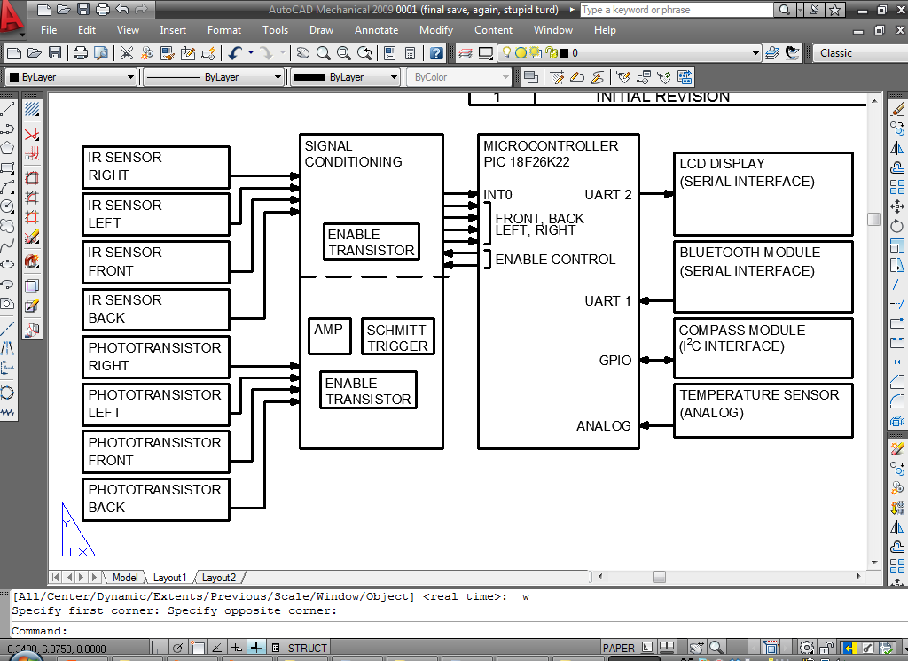
Due to the nature of Opticom devices, the MirrorMate team was unable to acquire an actual Opticom unit, or gather data directly from an Opticom beacon. The Opticom signal is simulated with the reduced speed zone beacon based on known characteristics of the Opticom carrier signal.
B. Reduced Speed Zone Beacon
For reduced speed zone detection the MirrorMate system requires an infrared beacon to be installed at driving hazards such as school zones, accident scenes, or construction zones. Contrary to the Opticom system which already exists, the reduced speed zone beacon is a new device designed by the MirrorMate team. The beacon is contained in a small plastic weather resistant enclosure and can be permanently mounted or placed at a road hazard temporarily. Cost was a significant consideration in beacon design to ensure the beacon is inexpensive to deploy. This is to encourage installation and extensive use of this safety device. The beacon encodes speed and zone
information into a 38kHz carrier signal.

Fig. 1. Sample Manchester Encoding

The signal is encoded via Manchester Coding similar to the RC5 remote protocol. The signal begins with a 4ms pulse followed by 4ms of silence. Two zeros are then transmitted and function as time calibration bits. The calibration bits are followed by 8 bits of data. A fully transmitted command is shown in Figure 1.
This method of encoding data is not currently utilized by any known IR devices which will ensure the beacon does not interfere with any device and vice-versa.
The beacon is easily configured for different speed zone situations via two push buttons and seven segment displays. The beacon features 50 high power 950nm IR
emitters for data transmission. Two different emitters were utilized for their optical characteristics. The SFH-4547 emitter from Oshram provides a wide beam pattern and the TSAL6100 emitter from Vishay provides a narrow, but high intensity beam pattern. The emitters are used together to obtain long distance transmission. The emitters are powered by a simple MOSFET amplifier.
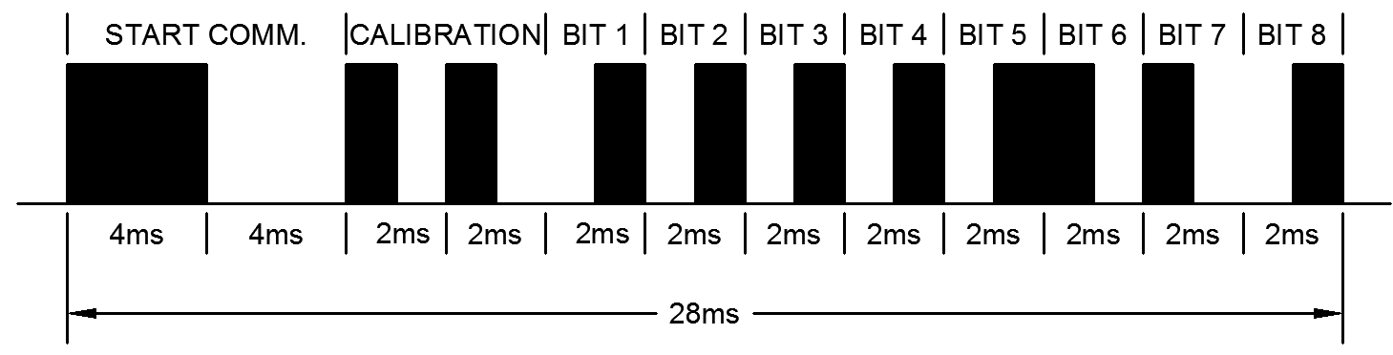
The beacon was designed to utilized a 6VDC power supply but can also be operated using power converters. The beacon can also be powered by mains voltages with a transformer. The power supply utilizes three LM1084 voltage regulators to establish the required voltage and current. Switching power supplies were avoided due to cost and design complexity.
All of the processing and signal generation required for the beacon is accomplished via a PIC 16F883 microcontroller. The beacon has provision for transmitting multiple signals at the same time (two channels with 25 emitters each) however, this feature is not currently utilized.

C. Infrared Receiver
MirrorMate features an advanced infrared receiver module designed to distinguish long distance IR signals. The IR module will receive and interpret two different types of signals, Opticom and reduced speed zone signals. Both of these signals are broadcast at the 950nm wavelength of the IR spectrum. Due to the vast differences between the Opticom signal and the reduced speed zone signal, MirrorMate’s IR receiver module will contain two distinct portions to detect the differing signals.
The Opticom system will be detected by its characteristic 14Hz carrier wave. The vehicle identification number will not be decoded as it is not practical or necessary to decode this information. The Opticom signal is detected via four phototransistors which are amplified and then utilize a Schmitt Trigger before reaching the microcontroller. Firmware configures the microcontroller to interrupt on an IR signal, and then programmatically determine if the signal is the correct Opticom signal. The receiver is directional and the microcontroller has been programmed to determine on which receiver(s) the signal has occurred. The result is displayed on MirrorMate's LCD, warning the driver of approaching emergency vehicles.
Information transmitted from the reduced speed zone beacon will be decoded from the 38kHz carrier similar to how a typical TV remote receiver operates. The receiver module will utilize 4 TSOP32338 IR receiver devices from Vishay. These devices automatically decode the raw speed and zone information from the 38 kHz carrier. The raw data is then interpreted by the microcontroller utilizing an interrupt and four I/O ports to determine direction. This method of communication was chosen to simply MirrorMate’s design. If photodiodes were utilized for this portion of signal detection, either a discrete signal decoder would be required, or processor intensive firmware would be needed. Additionally, the TSOP32338 devices have a proven track record for reliability and noise rejection.
To keep costs and design complexity to a minimum, no specially designed optics or lenses were employed in the reduced speed zone beacon or in the MirrorMate IR receiver.
The information sent to MirrorMate will be in one byte segments of information. The first four bits will be used to determine zone type and the second four bits will be used to determine appropriate speed through the zone. The correlation between the byte of data and driver alerts is detailed as follows in Figure 2.
For example, the byte transmitted to indicate a school zone with a speed limit of 35 would be 0x0A. When a valid byte is decoded, the information is displayed on the LCD to inform the driver.

First Encoded Char | Zone Type | Second Encoded Char | Zone Speed  (MPH)
0 | School Zone | 0 | 1
1 | Construction Zone | 1 | 2
2 | Accident Scene | 2 | 3
3 | Special Events | 3 | 4
4 | Not utilized | 4 | 5
5 | Not utilized | 5 | 10
6 | Not utilized | 6 | 15
7 | Not utilized | 7 | 20
8 | Not utilized | 8 | 25
9 | Not utilized | 9 | 30
A | Not utilized | A | 35
B | Not utilized | B | 40
C | Not utilized | C | 45
D | Not utilized | D | 50
E | Not utilized | E | 55
F | Not utilized | F | 60

Fig. 2. This figure shows the encoded byte for beacon data and the resulting zone type as displayed by the LCD

III. Bluetooth Systems
A. Bluetooth Hardware
The Bluetooth module is housed on a PCB inside the rear view mirror. The chosen Bluetooth adapter is the HC-05 and some of the key features include

- Bluetooth to UART Converter
- Class 2 4dBm Transmit Power
- Power Supply: +3.3VDC 50mA.
- Bluetooth Specification v2.0+EDR.
- Size:2.7cm x 1.3cm

The sufficient power, small size, and inexpensive price are the reasons the MirrorMate team is using this module. Furthermore, the ease of use and very little initial configuration allows this module to interface with the PIC18 microcontroller very well.

B. Bluetooth Connectivity
The Bluetooth Module is interfaced with the microcontroller through a serial UART connection. Both TX and RX pins are connected to I/O ports C7 and C6. The configuration is outlined in figure 3. Commands are sent to the Bluetooth Module from the MirrorMate Android application which is processed and converted to the serial TX data pin by the module.

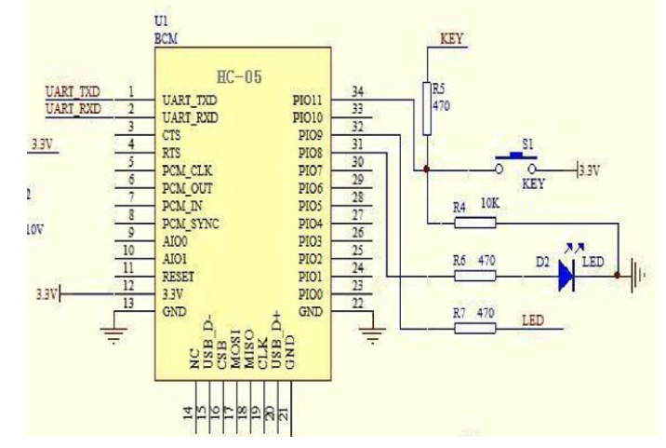
Fig. 3. Schematic and pin layout for the HC-05 Bluetooth Module.

The PIC18 microcontroller interfaces with the LCD and Bluetooth module through the two provided UART connections. UART1 is used for the Bluetooth, and UART2 is used for the LCD.
The firmware initializes UART by setting the calculated BAUD rate to 9600, disables both TX and RX interrupts, and enables asynchronous and 8-bit data mode. The PIC18 initializes UART once powered, before any communication with the LCD or Bluetooth occurs.
When the UART is configured, the PIC18 microcontroller actively listens for incoming data from the Bluetooth device. If data starts coming in, a buffer is created to store the incoming characters and waits for a terminator, which signals the end of the command.
Once all the UART data has been received from the Bluetooth device, the PIC18 microcontroller processes the data and prints it to the LCD.

IV. Magnetometer
A. Compass Hardware
The MirrorMate team chose the MAG3110 digital magnetometer to provide the cardinal directions that is located inside the rear view mirror. The main features include

- I2C digital output interface
- 1.95V to 3.6V Supply Voltage (VDD)
- Sensitivity of 0.10 μT
- 3-axis magnetometer

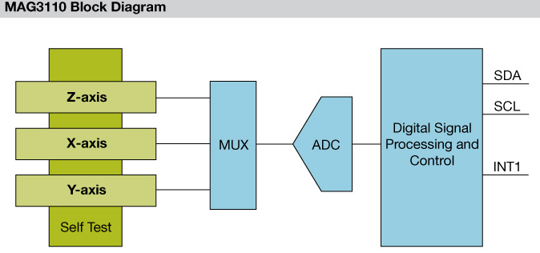
The MirrorMate team is using this digital compass because it’s inexpensive and a breakout board is provided. The breakout board allows easy integration into the rear view mirror. Without the breakout board, the MirrorMate team would have needed to solder a 2mm x 2mm device and calibrate the digital compass based on orientation on the final PCB. The block diagram is shown in figure 4.

Fig. 4. Block Diagram for the MAG3110 digital magnetometer used in MirrorMate. All information is pushed through the multiplexer before being sent to the PIC18.

B. Compass Connectivity
The digital compass is interfaced with the PIC18 through a software coded I2C interface. The PIC18 microcontroller used in MirrorMate only provides two UART ports. The first UART connection is used for the HC-05 Bluetooth module, and the second is used for the EzLCD. It was not until after the PCB was designed and printed before the MirrorMate team realized the PIC18’s shortcomings. Although a slight setback, the MirrorMate team is using two I/O pins and a software I2C interface to communicate with the digital compass. The two pins used on the PIC18 is RA0 and RA1. [2]
If the PIC18 needs to update the LCD on the rear view mirror, the microcontroller will communicate with the digital compass to get the current cardinal direction. The software I2C begins by configuring both register 1 and register 2. The digital compass needs to be set into continuous mode, which allows for continuous poling of the current cardinal direction.
Once both registers are configured, the firmware on the PIC18 begins to read the data on the compass. The data is read from six different registers that represent the low and high byte for the x, y, and z direction. Each must be poled in order for accurate data to be returned. The compass will be positioned inside the rear view mirror horizontally. Laying the digital compass horizontally allows the firmware to only use the x and y values returned to calculate which way the mirror is pointed. Each coordinate is show in figure 5. [3]
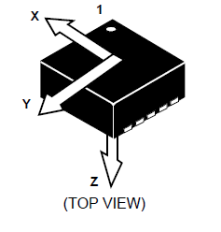

Fig. 5. This image represents the Cartesian direction based on the orientation of the chip. Special consideration was made to ensure that the chip was housed on the PCB in the correct position.

C. Software I2C
Communication is initialized by setting the assigned data pin latch to low. The physical address of the I2C address is sent followed by the read/write pin. If data is read from the I2C device, the read/write bit is set to high. If data is written to the I2C device, the read/write bit is set to low.
After the physical address of the I2C device is sent, data can be followed. When reading data, only the address that needs to be read is followed. When writing data, the address and the value assigned for that address needs to be sent in that order.
In between each read or write command sent over the software I2C, an acknowledgement is requested. This allows for errors to be caught within the code. If the data pin is high after a byte was sent, then an error occurred. If the data pin is low, then no error occurred and the next command can be sent.

V. Mobile Application
The MirrorMate system also includes a mobile application (App) developed for use with any smart phone running the Android Operating System version 2.3 (Gingerbread) and above. Utilizing the Android OS allows for the largest possible user-base for the MirrorMate system and because Android updates are backwards compatible any device running version 2.3 or newer is capable of running the MirrorMate application. Targeting Gingerbread allows for the application to run on slightly over 90% of all Android phones. [4]
Because the Android OS is largely open-source there are no barriers to entry for a beginning developer to create a functional application that can reach a tremendous user-base with little to no hassle. BlackBerry, Apple and Windows phones all require a fee to have access to development software for their devices.
The App requires the device to have an up to date version of Google Play installed on their phone as well as the Google Maps functionality. The App also requires the following permissions from the phone in order to function: Location – Coarse (network-based) and fine (GPS), Storage – Modify/Delete SD card contents, Network Communication – create Bluetooth connections, full Internet access, and System Tools – Bluetooth administration.
A. Software Development
The MirrorMate Application was developed utilizing the Eclipse Integrated Development Environment (IDE) with the additional Android custom plug-in Android Development Tools (ADT). It was also necessary to download and install the Android Software Development Kit (SDK) Tools as well as the Android version 2.3 SDK Platform. This App also required Android Support Library and the Google Play Services library to be included in the project directory in order to have access to the Google Maps service.
Development of the application took place on two separate phones to verify functionality and only minor differences were noticed between the two devices. Originally the target version was 2.2 which uses the Android Application Programming Interface (API) 8 but after some substantial development the target was changed to API 10 to allow additional functionality. Development for API 8 took place on a Motorola Defy that proved the map and navigation functions of the application. Development for API 10 took place on a Motorola Photon 4G and replicated all functionality of the mapping and navigation functions as well as implemented Bluetooth communication between devices.
No phones were available for testing of the application on a more recent version of the Android OS; however the ADT plug-in for Eclipse also includes an virtual emulator that can be configured to run on any API. For this reason the Android SDK API 17 was also downloaded in order to test the application on the emulator running version 4.2. Bluetooth Connectivity was not able to be tested by the emulator in this version however all other features were shown to perform admirably.
B. Bluetooth Pairing
When the user opens the App a “Pair Now” button is displayed immediately to allow for the user to connect their device to the MirrorMate mirror via Bluetooth. This allows for driving directions to be sent to the mirror and displayed for the driver in a helpful manner. The Bluetooth connection is an insecure connection which means that only one device is required for verification of connection. The pairing screen asks permission from the user to turn on the Bluetooth functionality of the phone if it has not been already enabled. If the user agrees to this they can then search for Bluetooth enabled devices nearby. The Bluetooth chip inside the mirror has sufficient range to allow communication to a device located anywhere inside a normal passenger vehicle. The mirror will be displayed with the name “HC-05” and the first time a user connects to it they will be required to enter a pass code in the form of a PIN. This PIN is “1234” and will only be required the first time the application connects with the mirror. The OS version development target was changed from version 2.2 to 2.3 in order to take advantage of the insecure Bluetooth connection methods that were not present in 2.2.
After the first connection between the App and the mirror the two devices will be considered “Paired” but “Not Connected” and “HC-05” will show up on a pop-up dialog of the phones paired devices each time the user attempts to start a new Bluetooth connection. Each Bluetooth chip has a unique MAC address and as a result the development chip and the final chip that is attached to the mirror PCB were both tested to ensure complete functionality. The Bluetooth connection will remain established as long as the App is open, but will disconnect once the user closes the app. Bluetooth connectivity is required to send driving directions from the phone to the mirror, but all other features of the application are able to be used without a Bluetooth connection if necessary.
C. Local Map
The App also allows for the user to view a map of the local surroundings of the phone via Google Maps. When the user presses the “Local Map” button from the App’s main menu the map will be displayed. This map is updated automatically with the user’s current location being displayed as a blue dot or arrow. This feature was added in order to provide the user with an easy to use digital map aid.
D. Driving Directions
From the App main menu a user can also tap the “Get Directions” button to request directions from their current location to a destination. This button replicates the Local Map display, but the user is also able to tap a location on the map to attempt to get directions to that destination. After the location is marked an alert dialog is shown with the marker’s address if the Reverse Geocoding request was successful. The application takes in the location of the tap on the screen and creates a Geopoint with the selected Latitude and Longitude. Reverse Geocoding is the process of looking for a street address nearest to the Geopoint and is a feature native to Android that does not require any additional coding or processing for the application. If the user confirms that this address is correct the application requests directions from the current location to the destination from Google via an HTTP request. A user can also type in the requested destination through an alternate alert dialog and avoid the reverse Geocoding process.

Fig. 6. This flowchart shows the flow of user interfaces throughout the MirrorMate application.

The HTTP request returns an XML document to the app, which is parsed for relevant information. All items in the XML document labeled “html_instructions” are extracted and put into an array of strings that are displayed to the user on the following screen. The “Directions List” screen shows all of the relevant turns to travel to the requested destination via a ListView item that allows the user to scroll and select the next direction. When the user taps the “Next Direction” button the direction description will have an arrow (-->) affixed to the beginning of it. If a Bluetooth connection is established the app also parses the string for important keywords like “Turn” or “Exit” and sends them to be displayed on the mirror. A “Previous Direction” button was also added that allows the user to resend an earlier turn and highlight the corresponding instruction. Both the Next and Previous buttons are disabled if the list does not contain another entry in that direction.
Additionally the XML document has the latitude and longitude of all turns in the itinerary. These points are used to highlight a path from the current location to the destination via a blue polyline on the map itself. While the line does not “snap-to” the roads on the map, it is still a helpful indicator of the route to display to the user.
VII. LCD Display
The ez-LCD-301 is 2.6” TFT LCD touch screen with a resolution of 400x240 that contains an LED backlight with 180 nit brightness. The LCD establishes communication when it is connected to microcontroller’s serial UART (Universal Asynchronous Receiver/Transmitter) port sending commands through the RS232 serial data in order to interpret and display notifications to the LCD screen. The module is extremely low power drawing less than 100mA and operates at a voltage of 3.3V making it compatible with the power supply needed for all components.
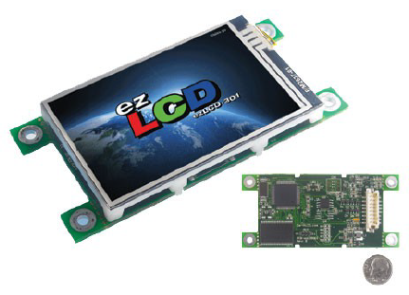

Fig. 7. Appearance and scale of the ez-LCD-301.

A. EARTHSEMPL

The software to program the ez-LCD is provided by Earth LCD. EARTHSEMPL is the programming language that uses macros that are called from the microcontroller to send all its commands to the LCD module. The language is designed around 7 widgets that can be displayed and modified by user-created macros.

Fig. 8. This figure shows the basic layout of the space utilization for the LCD module. Care was taken to ensure that all text was easily readable for a driver at arm’s length.

VIII. Microcontrollers
The MirrorMate The PIC18F26K22 architecture will be utilized as the device to interface all the peripherals included in the rearview of MirrorMate. This microprocessor, operating from 1.8V to 5.5V, features two EUSART modules. The EUSARTs are necessary as one will be used to communicate with the Bluetooth module and the other will be used to send ASCII commands to the ez-LCD 301.The hardware running at 64MHz is fast enough to be able hard code an I2C mode to receive updated cardinal directions from the compass. Another useful feature is the 10-bit Analog-to-Digital Converter to interface with the sensor for accurate temperature readings. The figure below details some of the most important features of the PIC18F.

\PIC18F26K22
Feature | Value
Max CPU speed | 64 MHz
Internal Oscillator | 16 MHz
Program Memory | 64 KB
Ram | 4 KB
Operating Voltage | 2.3V – 5.5V
DMA Channels | 4
Parallel Port | PMP
UART (featuring IrDA, RS232, SPI, I₂C) | 2
Real-Time Clock and Calendar | Yes
Packages available | PDIP, SSOP, QFN,SOIC

The reduced speed zone beacon is powered by a PIC 16F883 microcontroller from Microchip. This chip was chosen due to peripherals, I/O pin quantity, popularity, and user base. A chip with plentiful I/O ports is necessary as the 16F883 is driving the two seven segment displays directly with no multiplexing or discrete logic. This method was chosen to simplify design. Two PWM modules are utilized for the two separate transmission channels in the reduced speed zone beacon (25 LED’s each). This allows the beacon to transmit two different signals at one time, however this feature is not utilized. The on-chip EEPROM is used to save the current configuration of the beacon which is recalled on power up.
IX. TEMPERATURE SENSOR
The Linear Active Thermistor™ IC uses an internal
diode to measure temperatures that provides a change in voltage based on the relative ambient temperature from -40°C to 150°C. The voltage output pin (VOUT) can be directly connected to the ADC input of a microcontroller. The MCP9701 temperature coefficients are scaled to provide a 1°C/bit resolution for an 8-bit ADC The change in voltage is scaled to a temperature coefficient of 10.0 mV/°C (typical) for the MCP9701. This linear scale is
described in the first-order transfer function shown below is used to calculate the temperature.

VOUT = TC • TA + V0°C
TA = Ambient Temperature
VOUT = Sensor Output Voltage
V0°C = Sensor Output Voltage at 0°C
TC = Temperature Coefficient
X. Conclusion
The MirrorMate project was completed with little to no scaling-down of the original ideas and goals the team created 6 months ago. The MirrorMate system would be a valuable asset to any traveler as well as a useful aid to any area that implemented the safety features provided by the emergency beacon and emergency vehicle detection systems.
The team has learned an incredible amount of information. The MirrorMate project was created to encapsulate many Electrical and Computer Engineering concepts that will carry over into the team’s careers.

Acknowledgement
The authors wish to acknowledge the assistance and support of Dr. Samuel Richie, Erich Koryn, Ralph Simons, Dr. Lei Wei, Dr. Ronald DeMara, Richard Owen, Wade Lester and Tyler Milliken.

Biographies

Jake Hochstadt is a 23 year old student at the University of Central Florida pursuing his Electrical Engineering degree. After graduation, Jake plans to pursue his career with NASA at Kennedy Space Center. His interests include web development, electronics, and hardware/software integration.

Ryan Moreland is completing his Bachelor’s degree in Computer Engineering with a minor in Computer Science. Following graduation Ryan intends to continue his career in computer systems with a special interest in overseeing hardware software integration. Ryan is interested in electronics, as well as software development especially for mobile devices, and enjoys running in his spare time.

Matt Simons is studying Electrical Engineering at UCF. After graduation Matt plans to continue his career in the defense industry. Matt is a member of IEEE and specializes in microcontrollers and board level electronics. Matt has an interest in applying wireless communication and unmanned aerial systems principles to defense applications.

Jerome Yearwood is studying Electrical Engineering at UCF. After graduation Jerome endeavors to pursue a career in integrated circuit and silicon design, specifically microcontrollers and FPGA. Jerome’s interests include user interface design and display integration.

References

[1] “GTT OptiCom 795H Installation Manual,” Global Traffic Technologies, LLC., Rev A, pp. 7-8, 2007.Android, .
[2] Weiss, Aaron. "MAG3110 Breakout Example Code." Sparkfun. N.p., 06 Sep 2011. Web. 2 Apr 2013. <https://www.sparkfun.com/products/10619>
[3] Advance, Information. "3-Axis, Digital Magnetometer." . Freescale Semiconductor, 01 May 2011. Web. 2 Apr 2013.
[4] "Dashboards - Platform Versions." Android Developers. Android, 02 Apr 2013. Web. 2 Apr 2013. <(http://developer.android.com/about/dashboards/index.html>.

